**UNEARTHING THE ENVIRONMENTAL IMPACT OF HUMAN ACTIVITY - A GLOBAL CO2 EMISSION ANALYSIS**

**1.INDRODUCTION:**

**1.1 Overview:**

* **Carbon dioxide (CO2) is a greenhouse gas that is emitted by human activities such as burning fossil fuels, deforestation, and industrial processes. These emissions contribute to climate change, which has significant impacts on the environment, human health, and the economy.**
* **According to the Intergovernmental Panel on Climate Change (IPCC), global CO2 emissions have increased by about 50% since 1990, with the majority of these emissions coming from the burning of fossil fuels such as coal, oil, and natural gas. In 2019, the world emitted approximately 34 billion metric tons of CO2, with China being the largest emitter, followed by the United States and India.**
* **The consequences of increasing CO2 emissions are severe and include rising global temperatures, sea level rise, changes in precipitation patterns, and more frequent and severe weather events such as hurricanes and droughts. These changes can have significant impacts on ecosystems, agriculture, water resources, and human health.**
* **Efforts to reduce CO2 emissions include increasing the use of renewable energy sources, improving energy efficiency, and implementing policies such as carbon pricing and emissions regulations. The transition to a low-carbon economy is crucial to mitigating the impacts of climate change and ensuring a sustainable future for generations to come.**

**1.2 Purpose:**

* New **opportunities to use carbon dioxide (CO2) in the development of products and services are capturing the attention of governments, industry and the investment community interested in mitigating climate change as well as in other factors, including technology leadership and supporting a circular economy. This analysis considers the near-term market potential for five key categories of CO2-derived products and services: fuels, chemicals, building materials from minerals, building materials from waste, and CO2 use to enhance the yields of biological processes.**
* **All five categories could individually be scaled-up to a market size of at least 10 MtCO2/year – almost as much as the current CO2 demand for food and beverages – but most face commercial and regulatory barriers. CO2 use can support climate goals where the application is scalable, uses low-carbon energy and displaces a product with higher life-cycle emissions. Some CO2-derived products also involve permanent carbon retention, in particular building materials. A better understanding and improved methodology to quantify the life-cycle climate benefits of CO2 use applications are needed.**
* **The market for CO2 use is expected to remain relatively small in the short term, but early opportunities could be developed, especially those related to building materials. Public procurement of low-carbon products can help to create an early market for CO2-derived products and assist in the development of technical standards.**

**2.Problem Definition & Design Thinking:**

**What are the problems arising while co2 emissions.**

**2.1 EmpathyMap:**

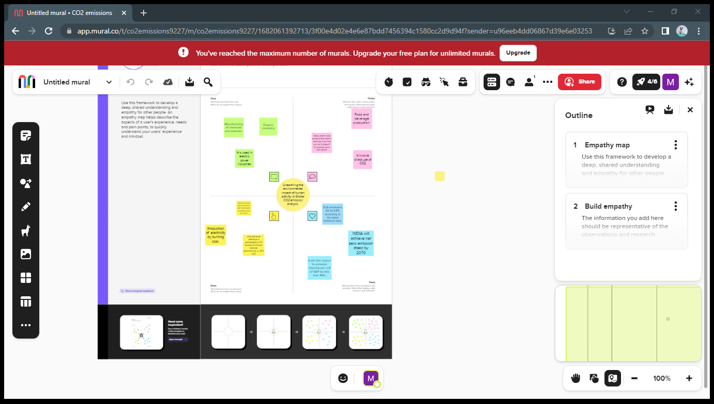

**2.2 Ideation &Brainstorming Map:**

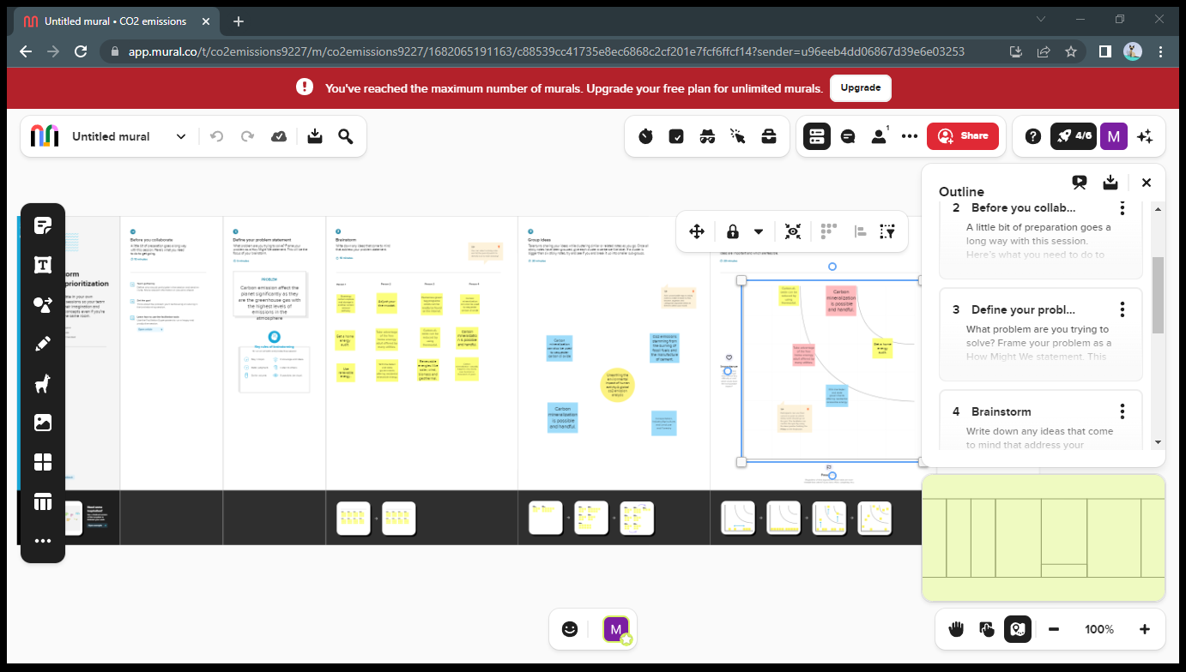

**3.RESULT:**

**Tableau output:**

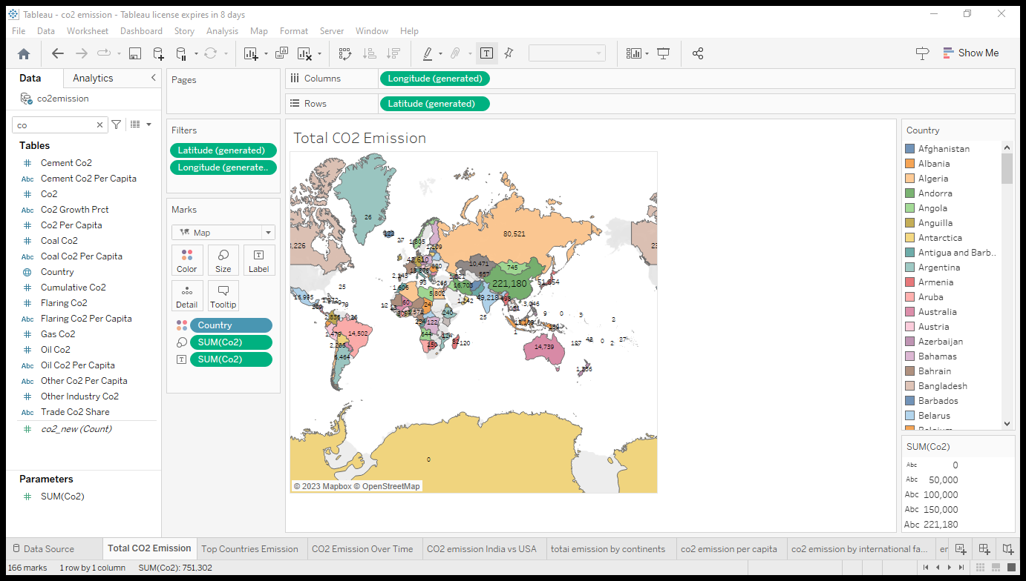

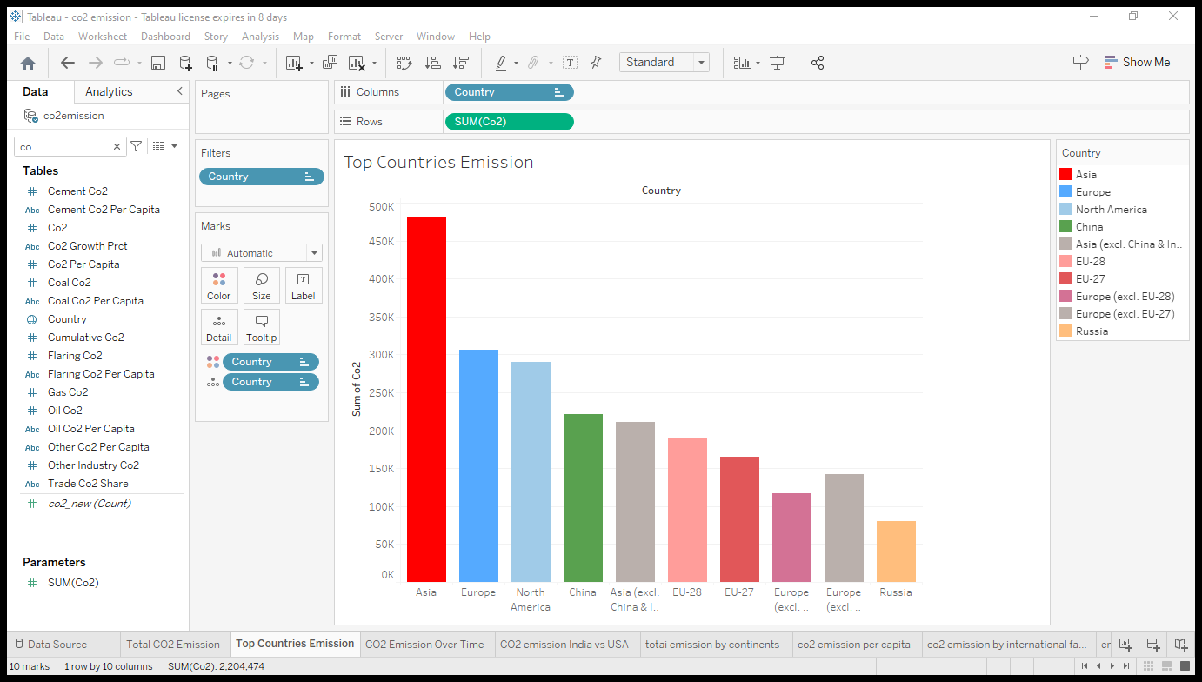

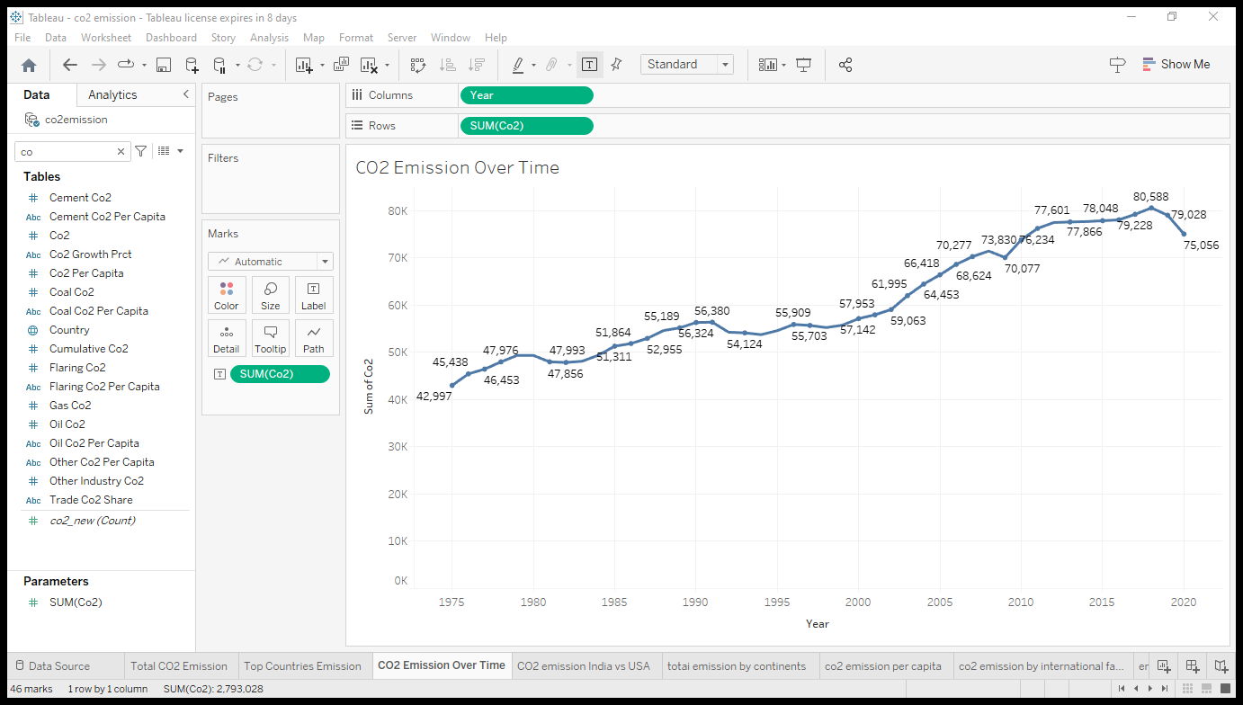

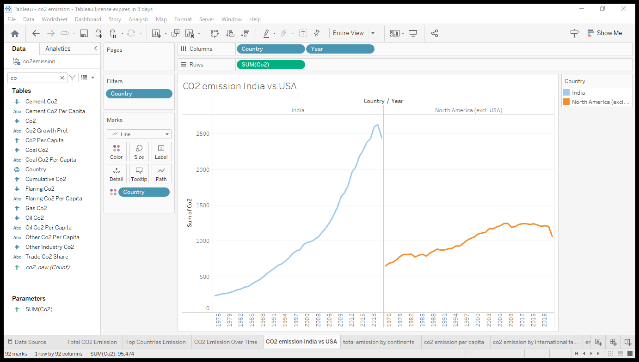

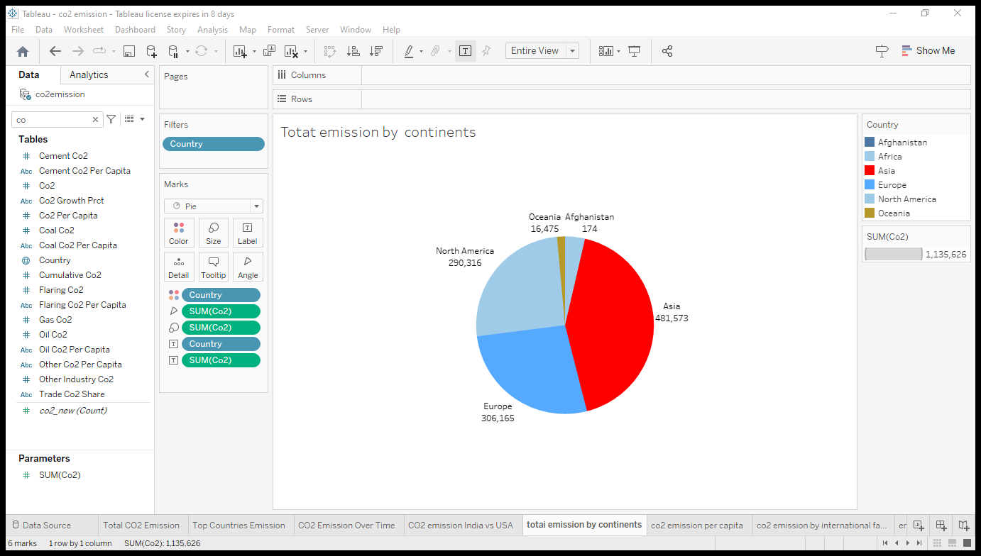

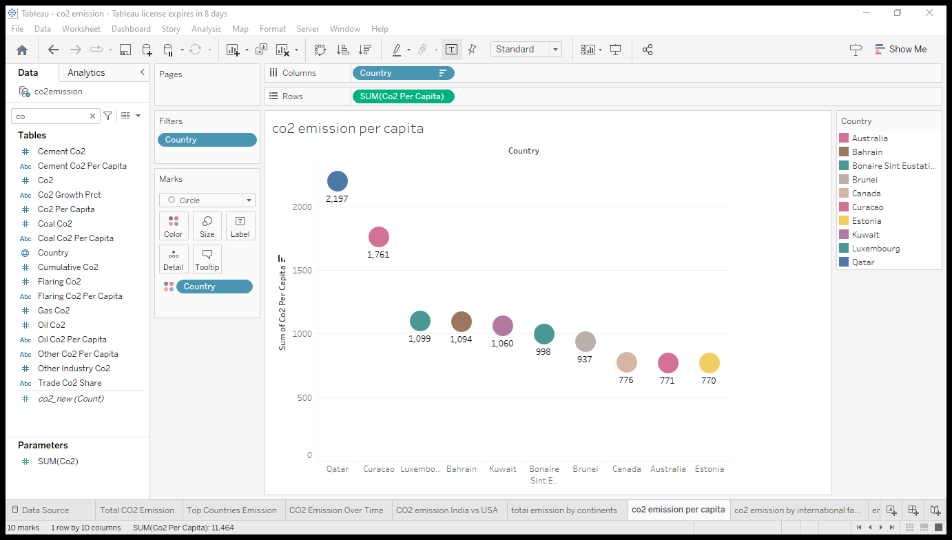

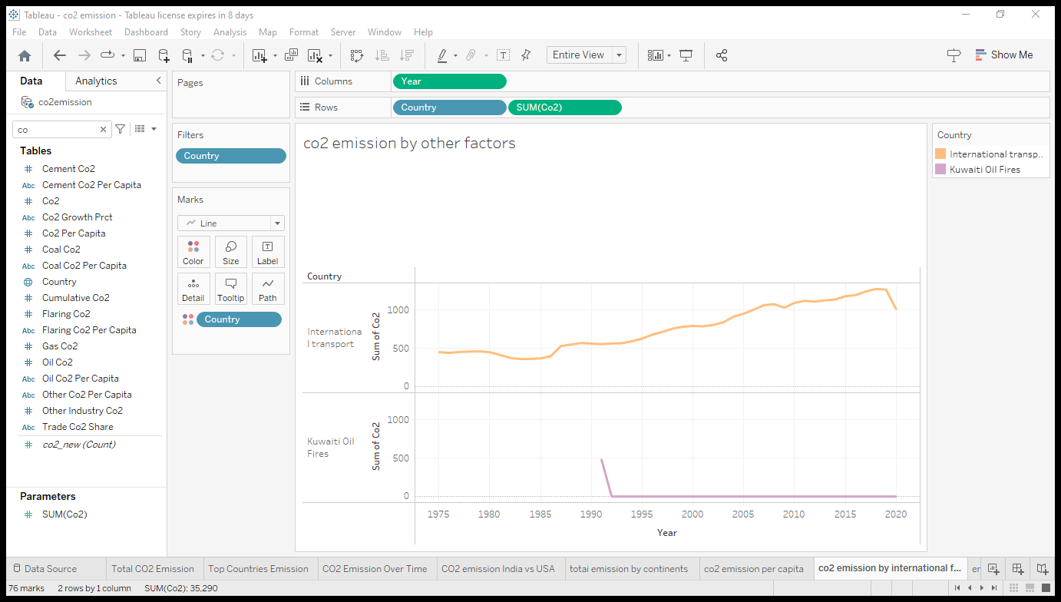

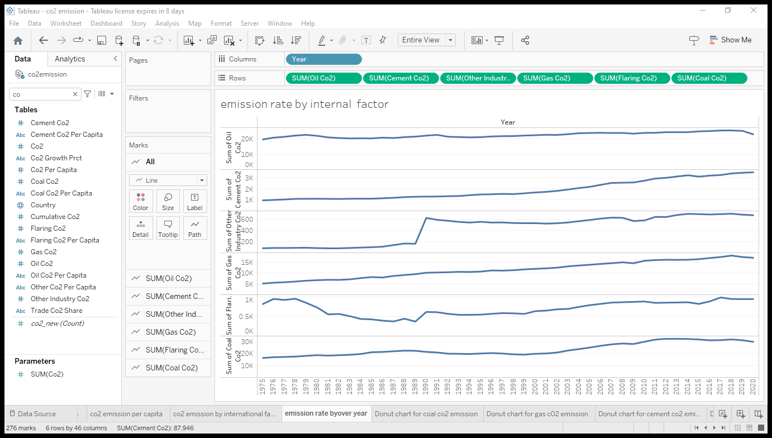

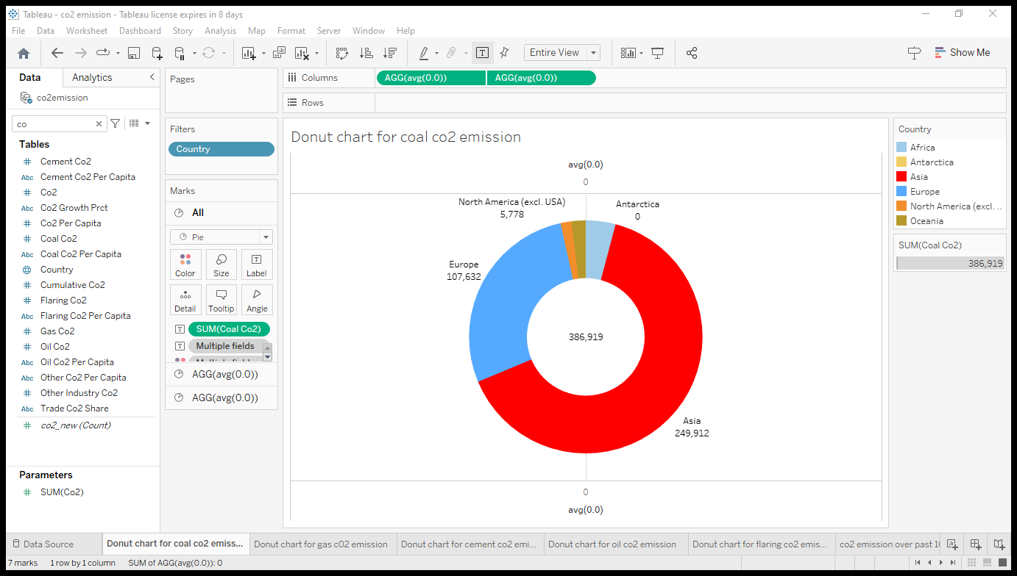

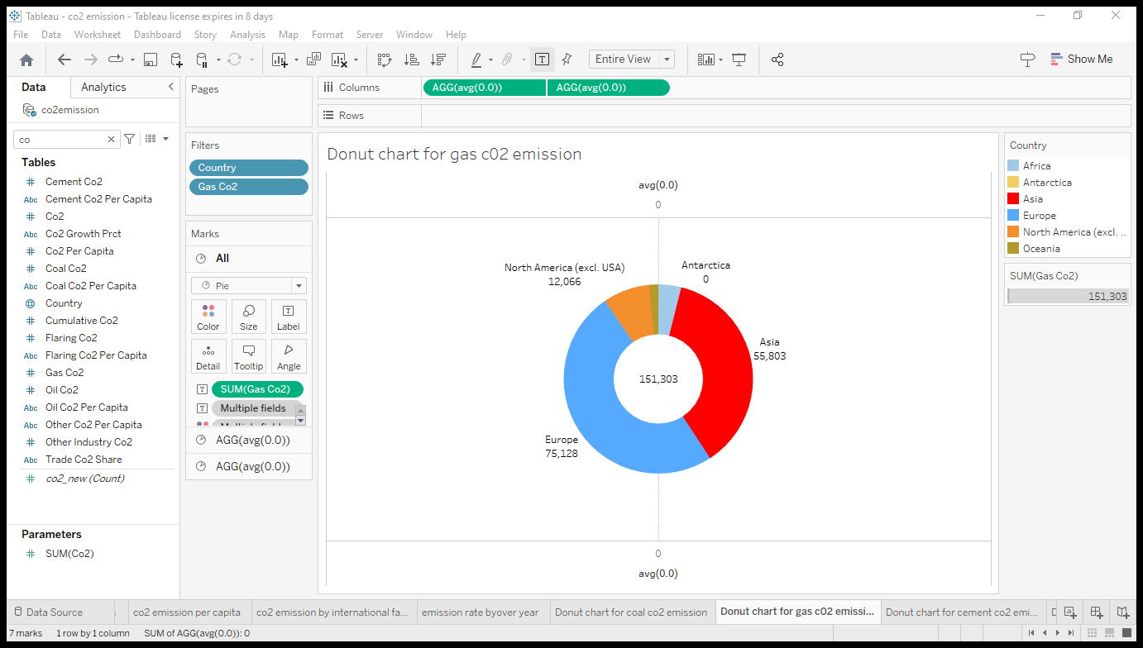

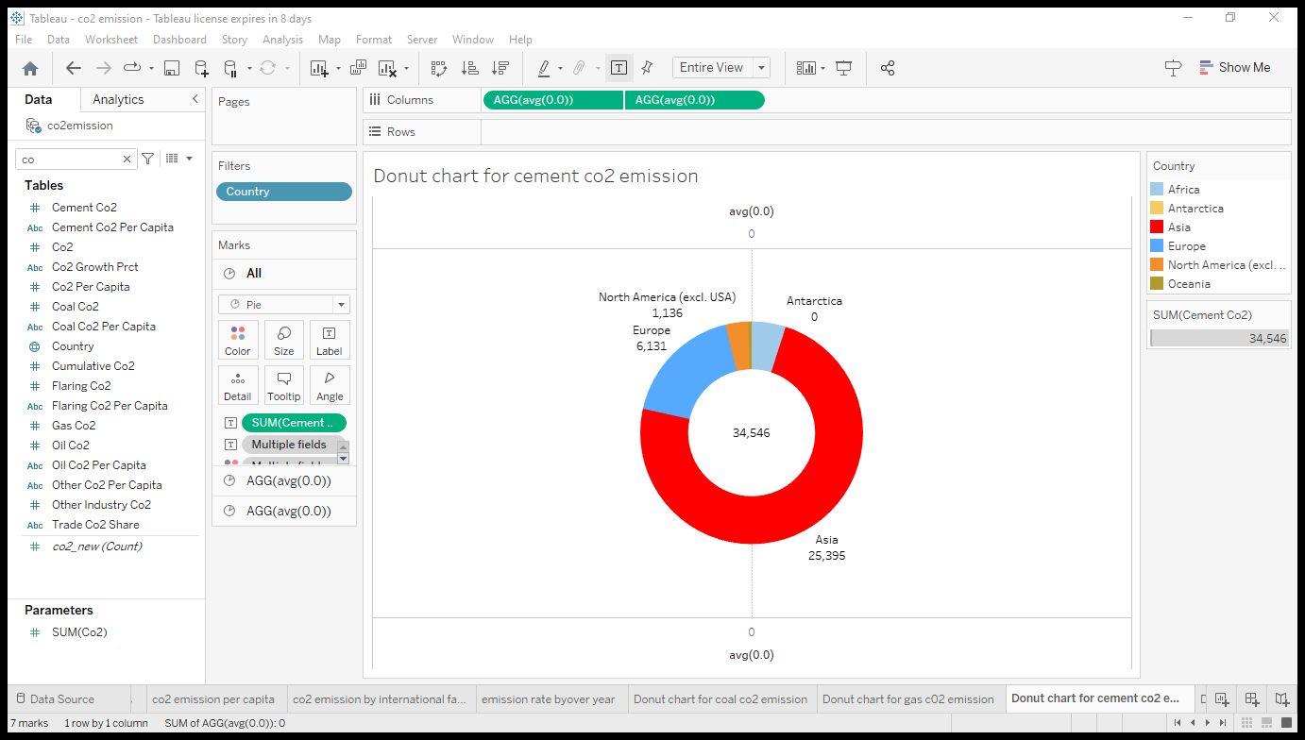

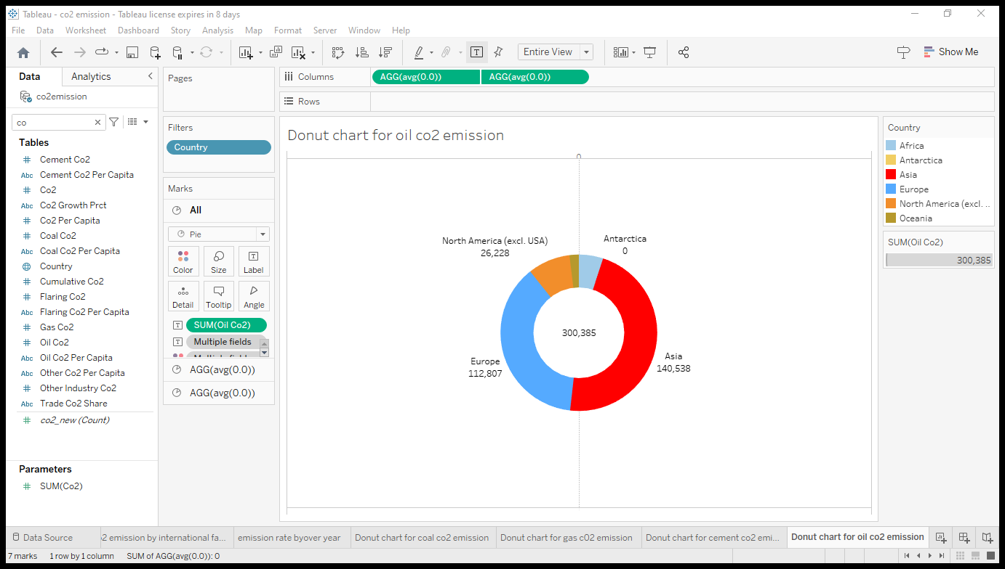

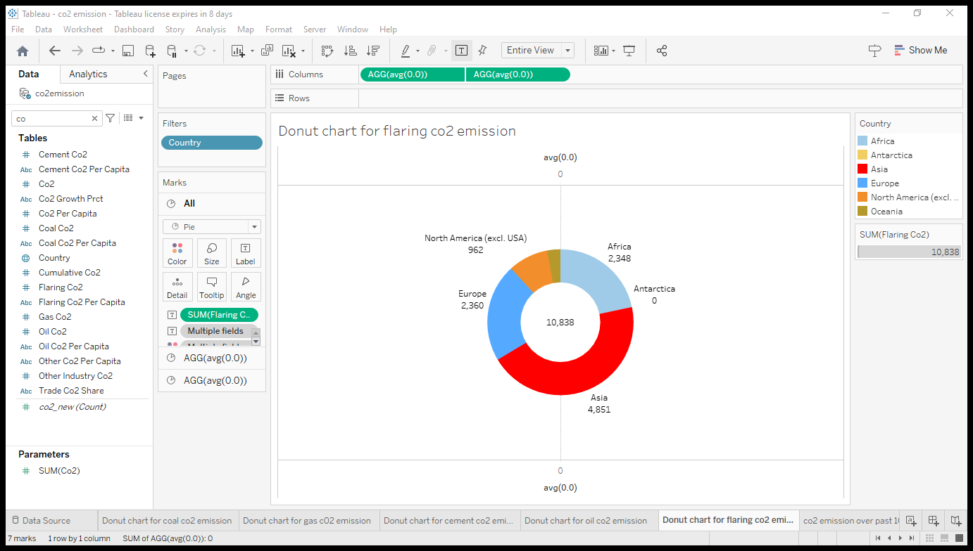

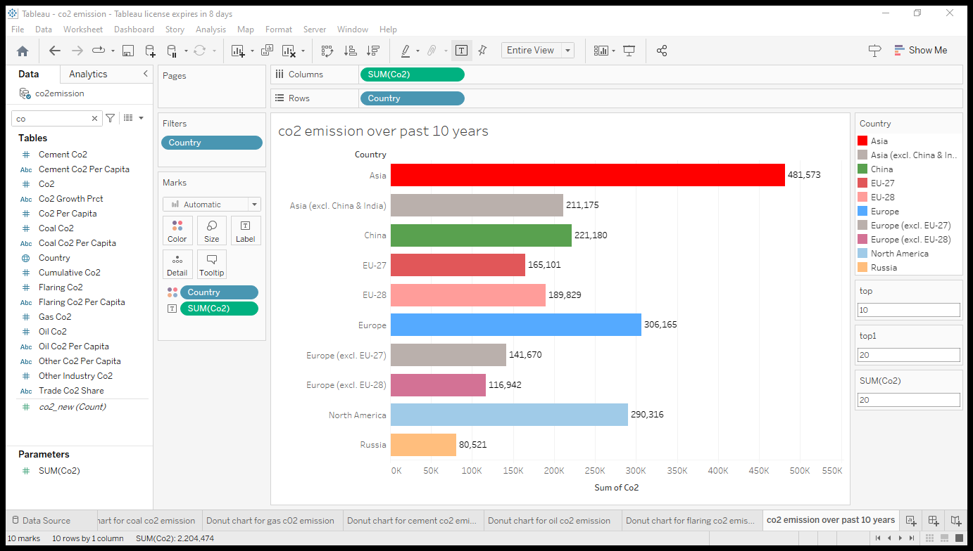

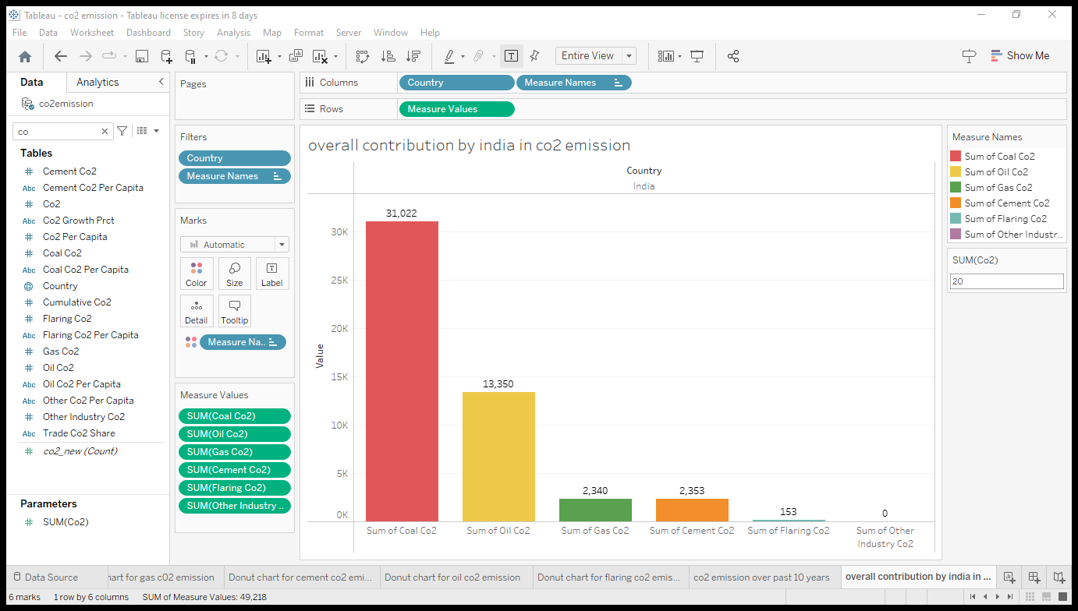

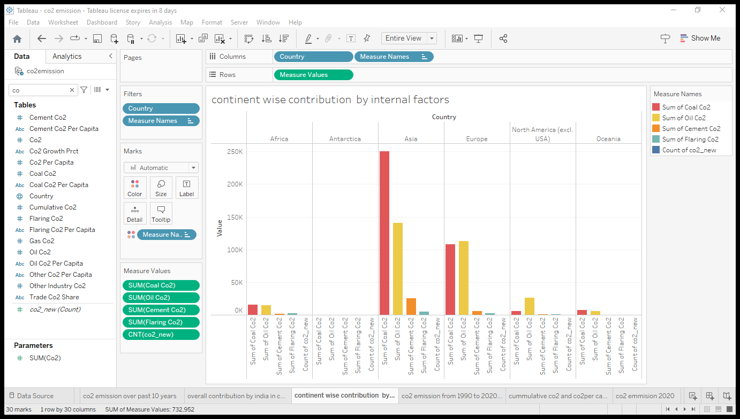

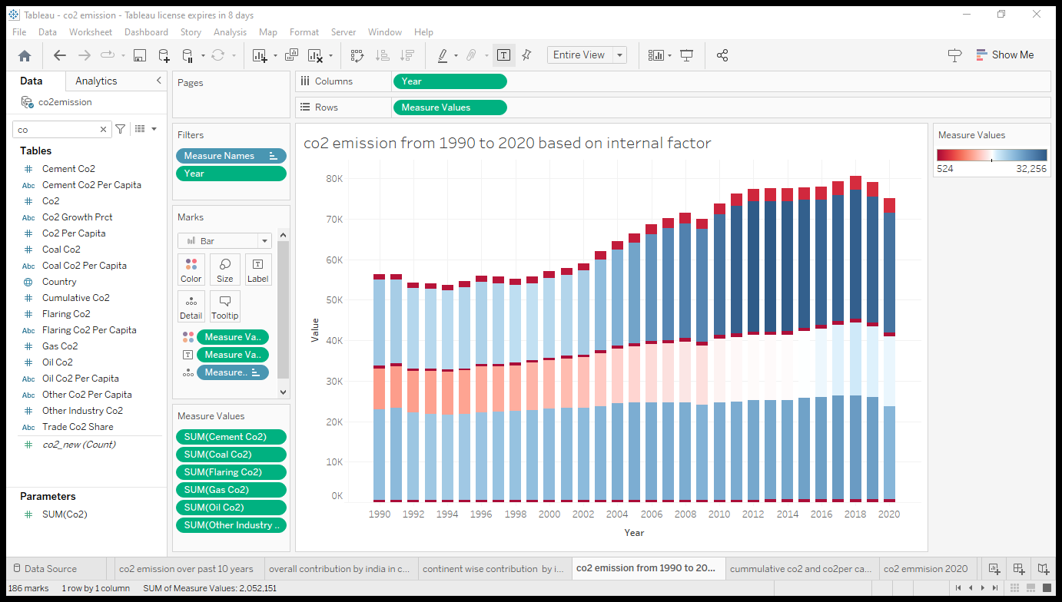

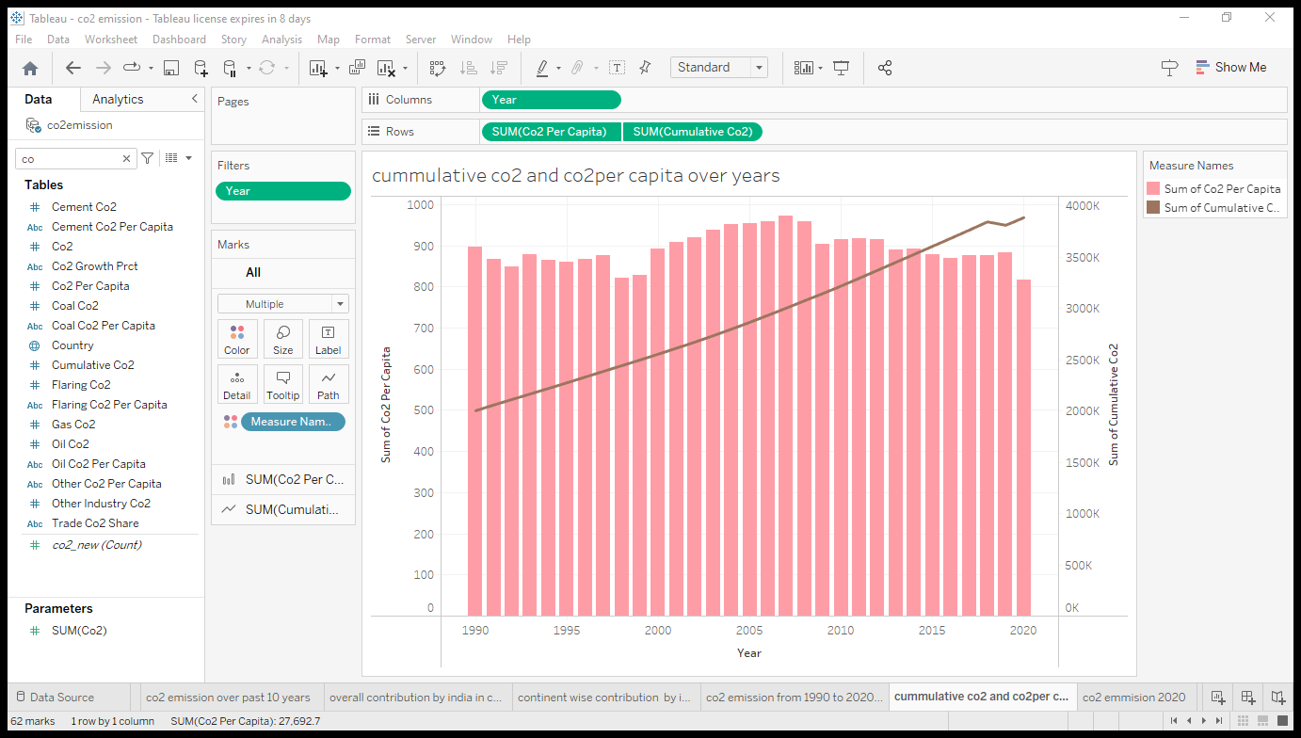

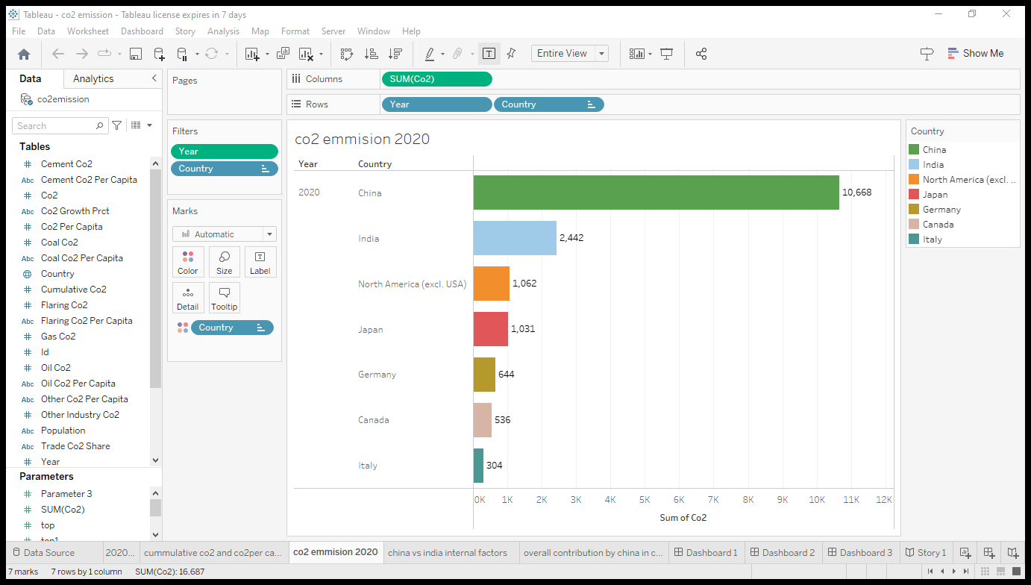

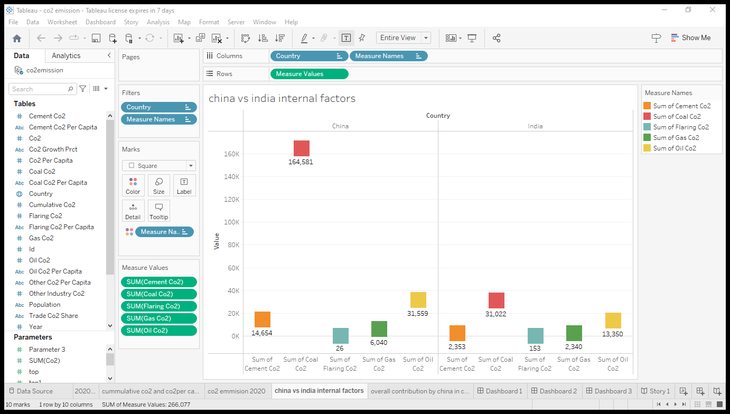

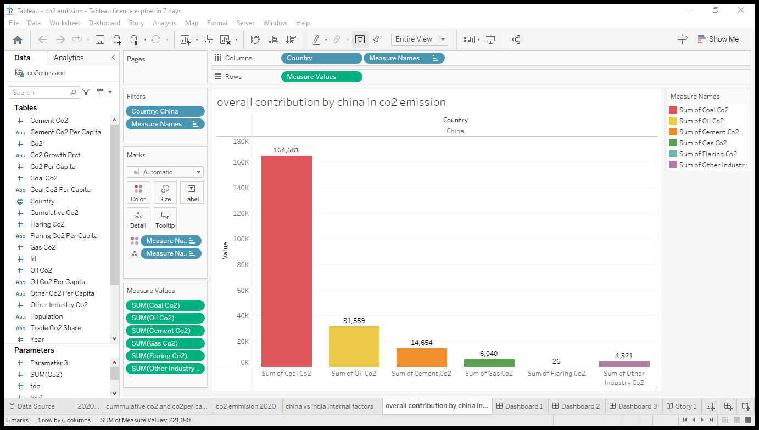

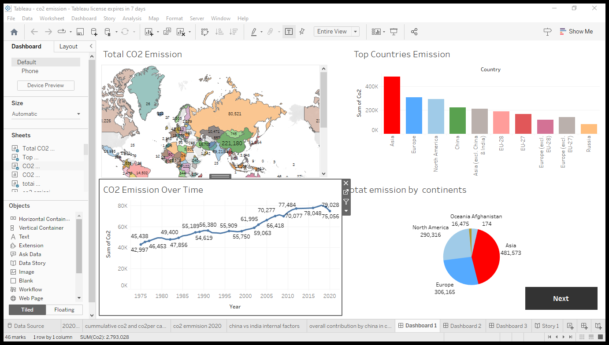

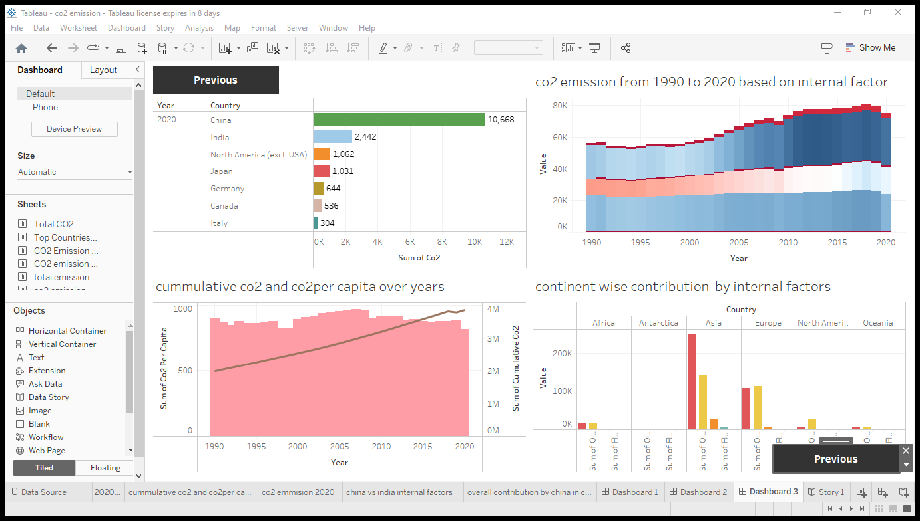

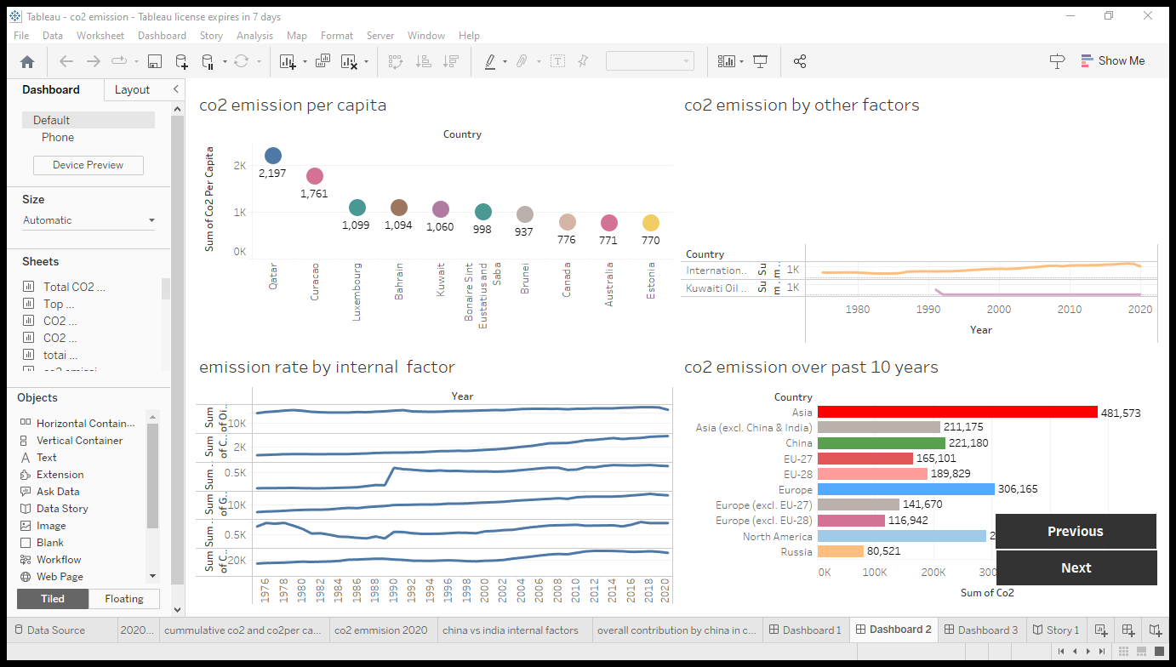

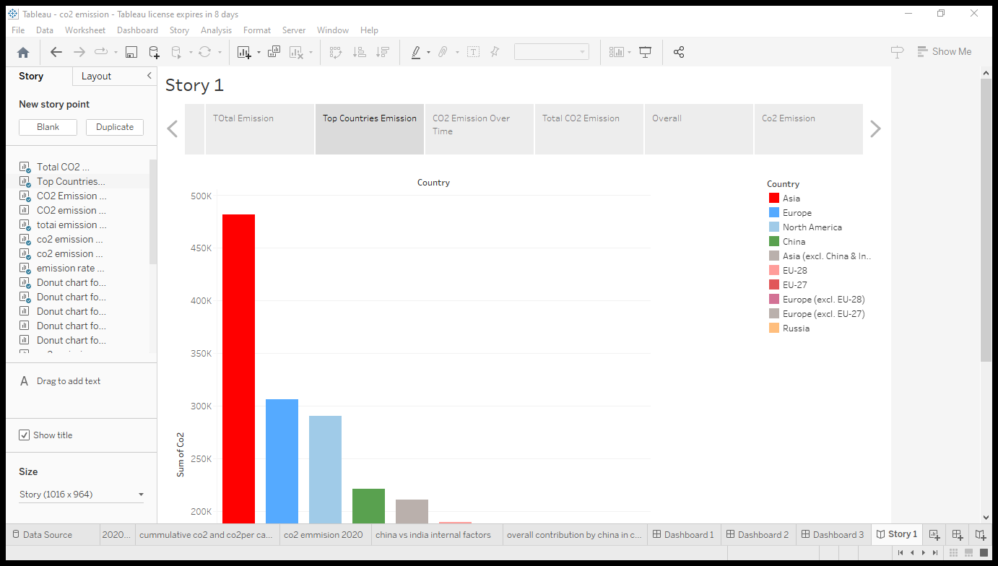

**4.ADVANTAGES&DISVANTAGES:**

**4.1 Advantages:**

* **By absorbing extra carbon dioxide from the atmosphere, carbon sequestration prevents the occurrence of climate change.**
* **The deep injection is feasible since the gas can be easily liquefied and transmitted easily through pipelines.**
* **Deep injection of carbon dioxide improves the extraction of fuels like oil and methane from their reserves in addition to removing excess pollutants from the air.**
* **In the foreseeable future, coal is not anticipated to be totally replaced by renewable energy sources like solar and wind. Yet, carbon sequestration may make it possible to lower emissions by 80% to 85% while still using fossil fuels.**
* **There haven’t been any events of carbon dioxide leaking out from the injection site, and it won’t happen for 1000.**

4.2 Disadvantages:

* **Implementing carbon sequestration in power plants costs money and calls for 40% additional coal. Sequestration is also anticipated to increase the cost of energy by 1 to 5 cents per kilowatt hour.**
* **Carbon dioxide from power plant emissions must be captured and liquefied, which uses a lot of electrical power. Already, the operation of such plants consumes 20% of the energy they produce.**
* **It could be disastrous if the injected gas leaks due to structural flaws in the geological formation.**
* **This is particularly true because carbon dioxide would remain close to the land surface because it is denser than air.**
* **The concentration of carbon dioxide gas from power plant exhaust is too low for being effectively liquified.**
* **The ocean can become acidic due to the large amounts of carbon dioxide being injected into it, endangering aquatic life. Due to the elevated levels of carbon dioxide in the atmosphere, the oceans are already very acidic.**

**5.APPLICATIONS:**

* Carbon dioxide is used as a refrigerant, in fire extinguishers, for inflating life rafts and life jackets, blasting coal, foaming rubber and plastics, promoting the growth of plants in greenhouses, immobilizing animals before slaughter, and in carbonated beverages.
* Clearer Air & Skies – reducing our carbon emissions helps reverse the impact of global warming overall, but more specifically, benefits the overall air quality. Plus, it makes for clearer skies.
* Save Money – the simple reduction of energy shrinks your carbon footprint and operating expenses.
* CO2 is also widely used in food and beverage production, the fabrication of metal, cooling, fire suppression and in greenhouses to stimulate plant growth.

6.CONCLUSION:

* Carbon capture and sequestration is an attractive option for reducing greenhouse gas emissions and could even help remove carbon dioxide from the atmosphere. A decisive advantage of CCS is that its technological feasibility has been proven and that it has been implemented on projects dating back several decades.
* Its main fault is that it is still too expensive and too uncertain to truly mobilise the economic actors.
* The reluctance of local authorities and the cautiousness of communities often complicate projects and obscure the prospects of a technology that, for the time being, remains an uncertain deus ex-machina.

6.1 Dashboart:

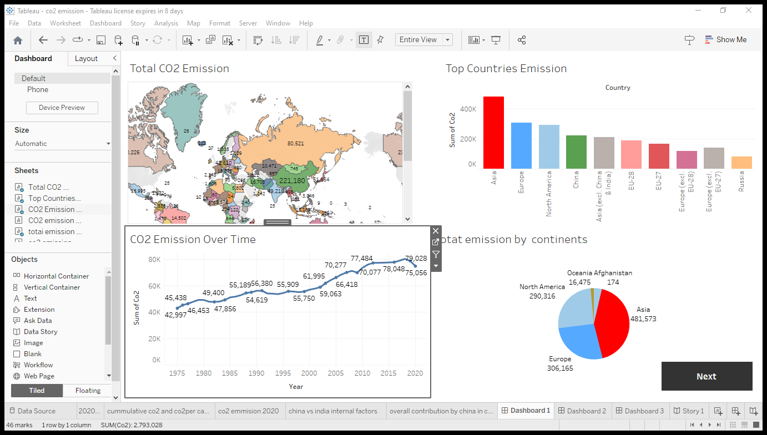

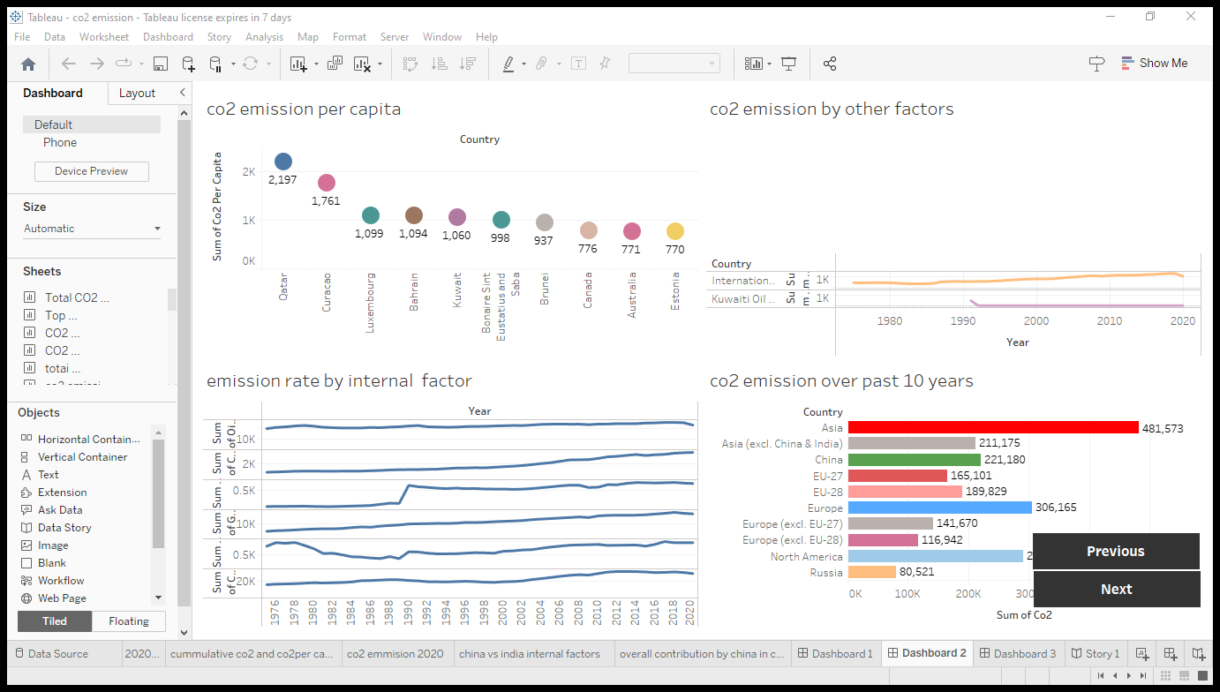



6.2 story:

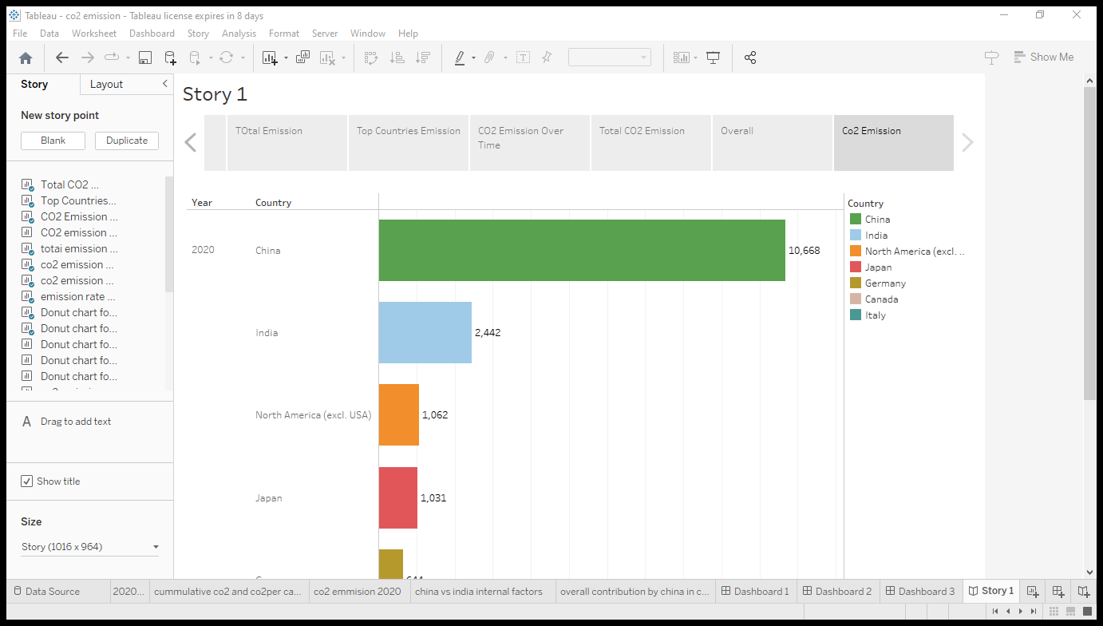

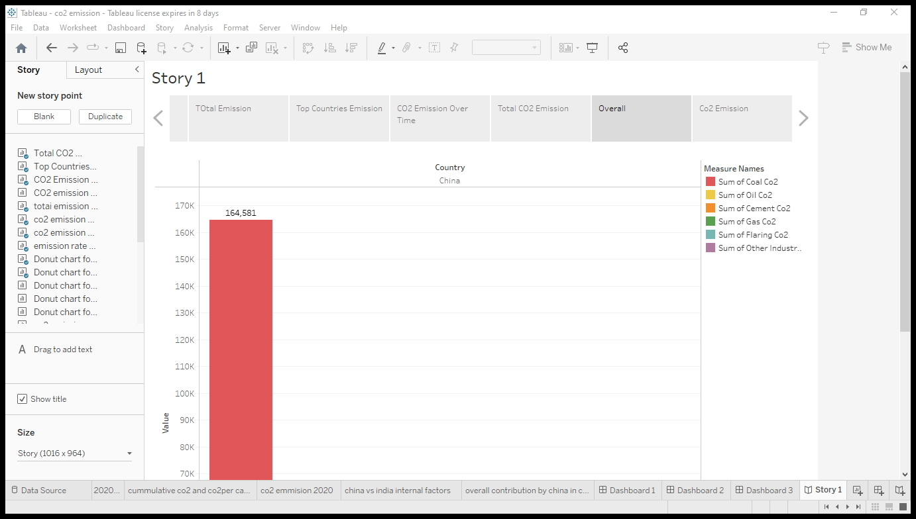

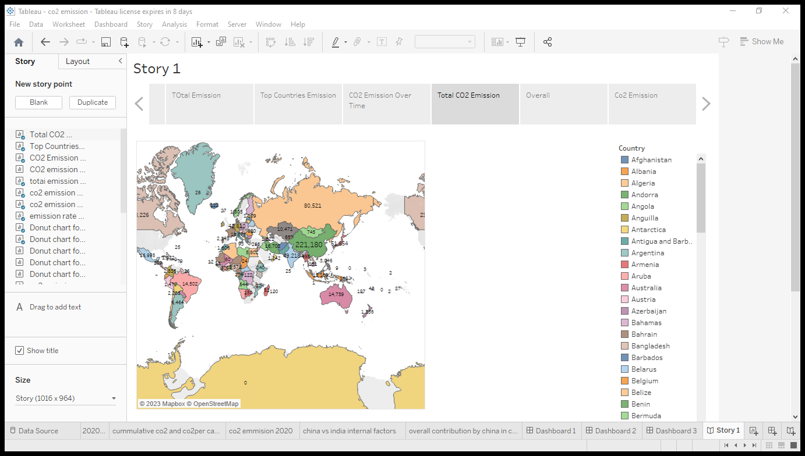

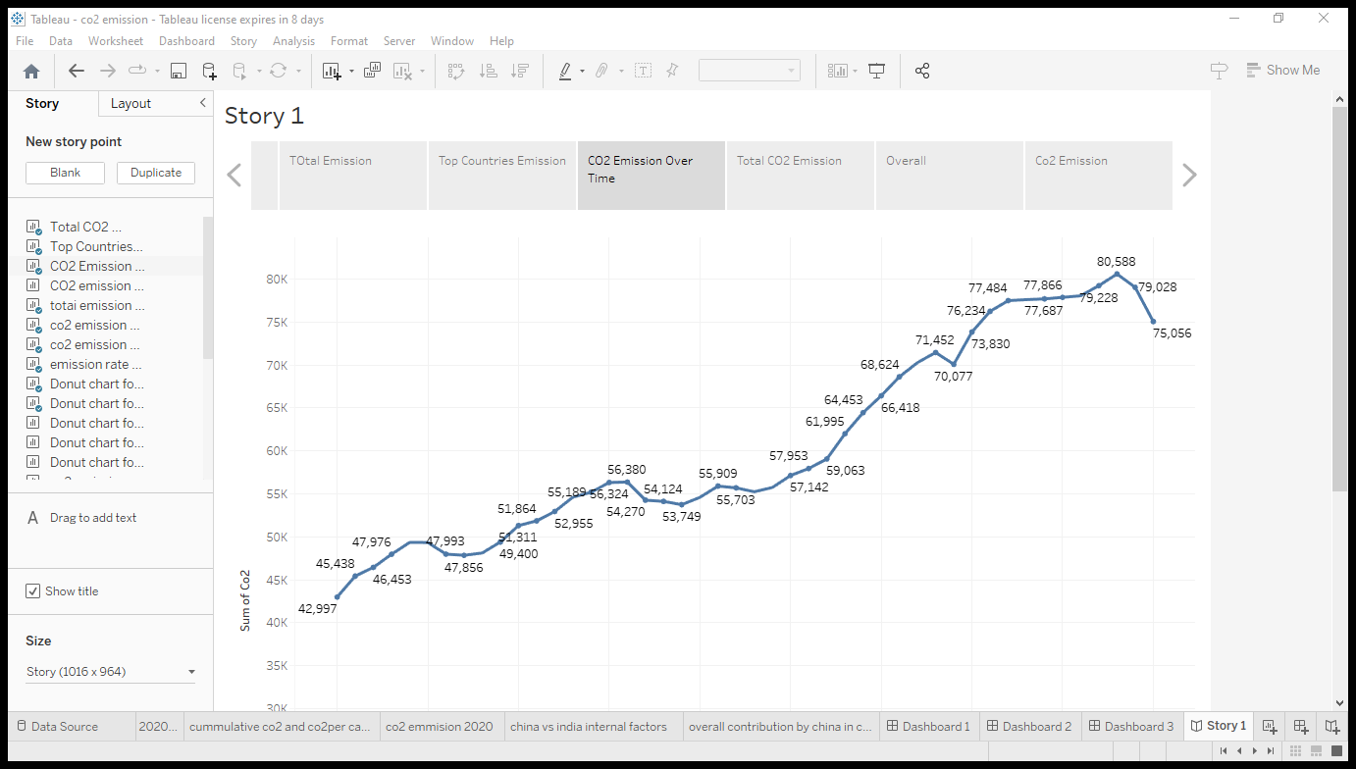



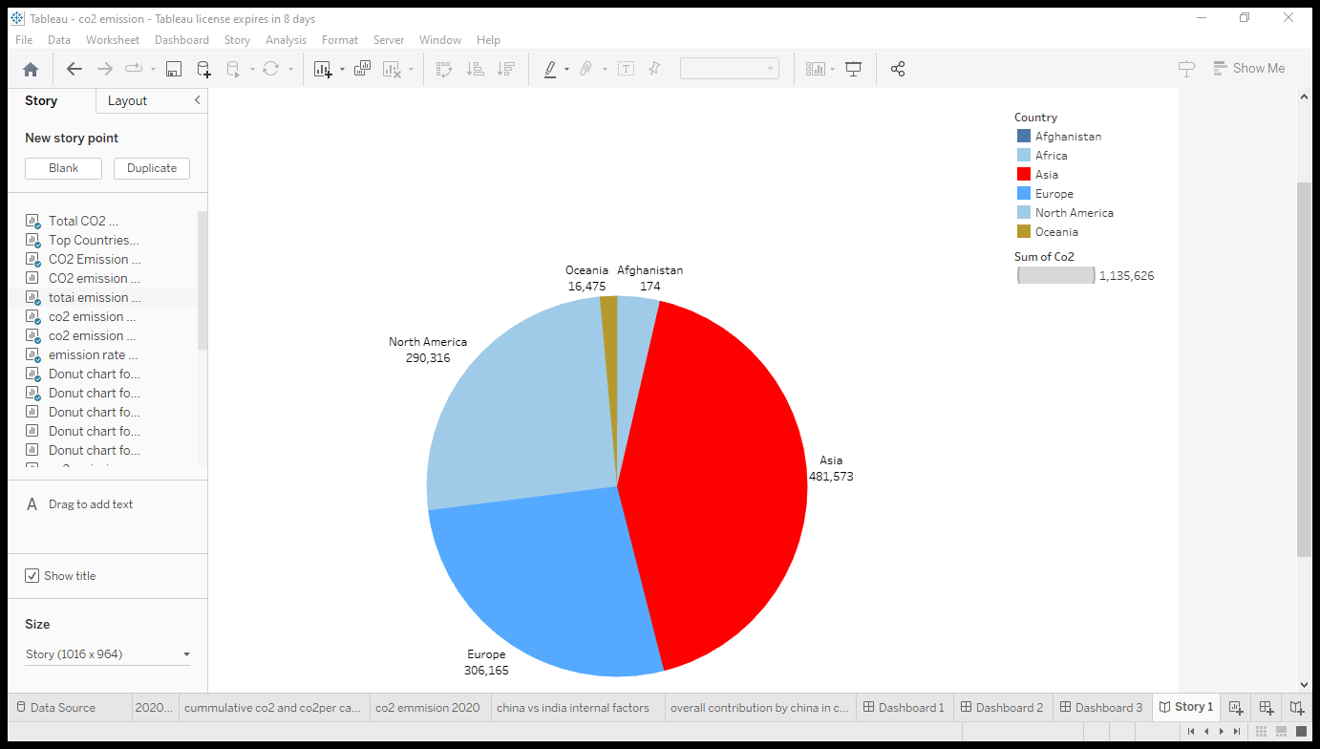

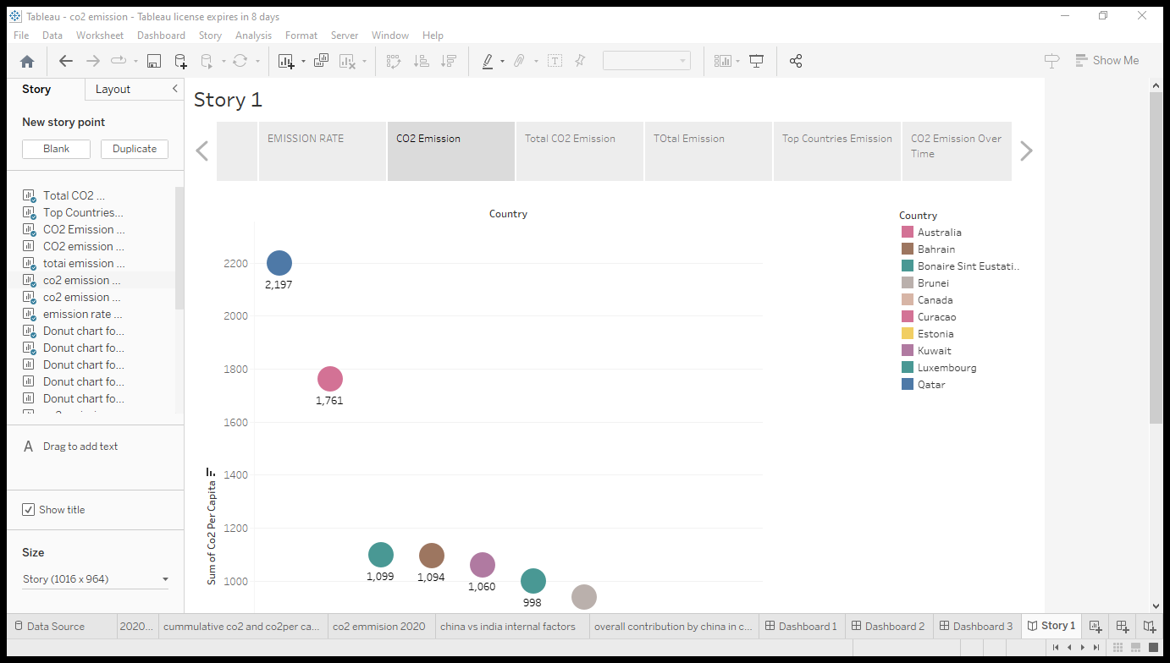

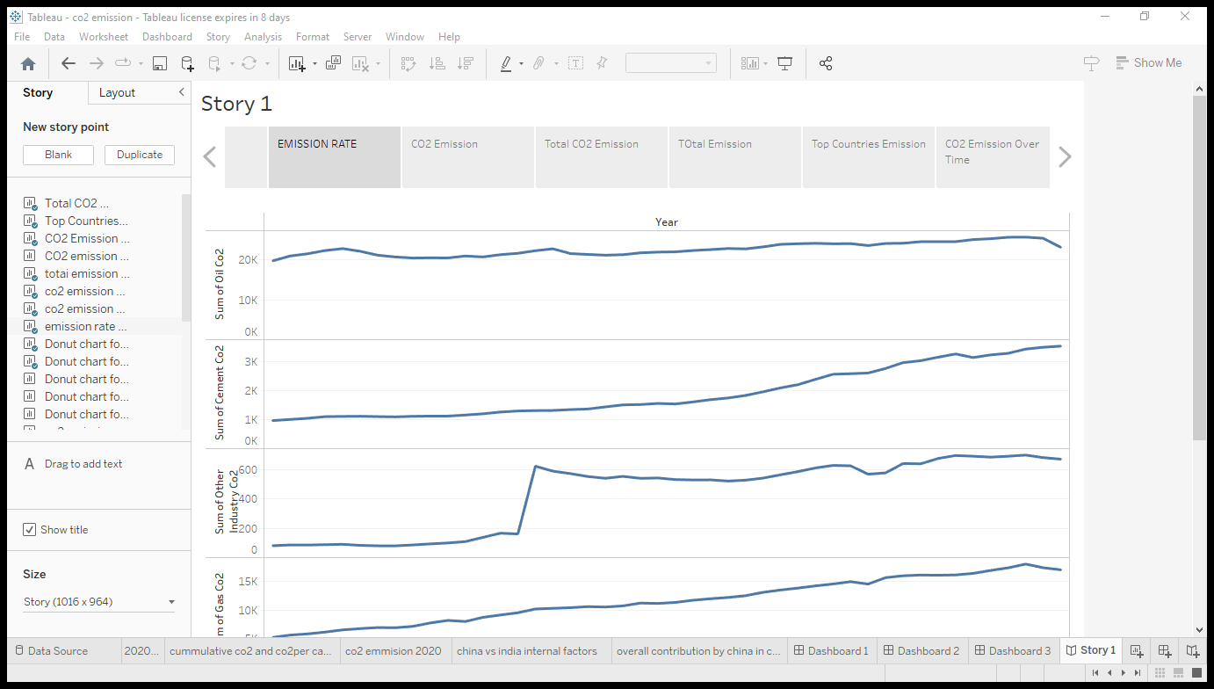

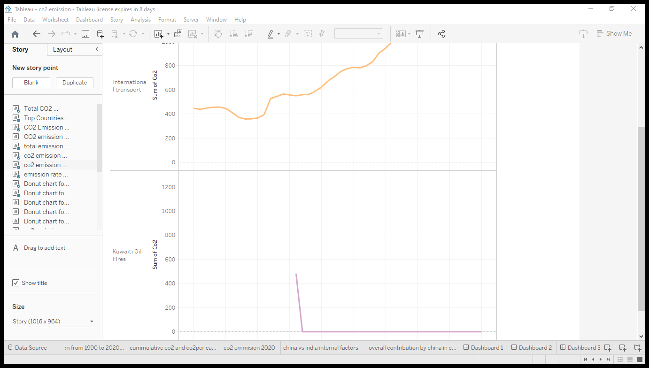

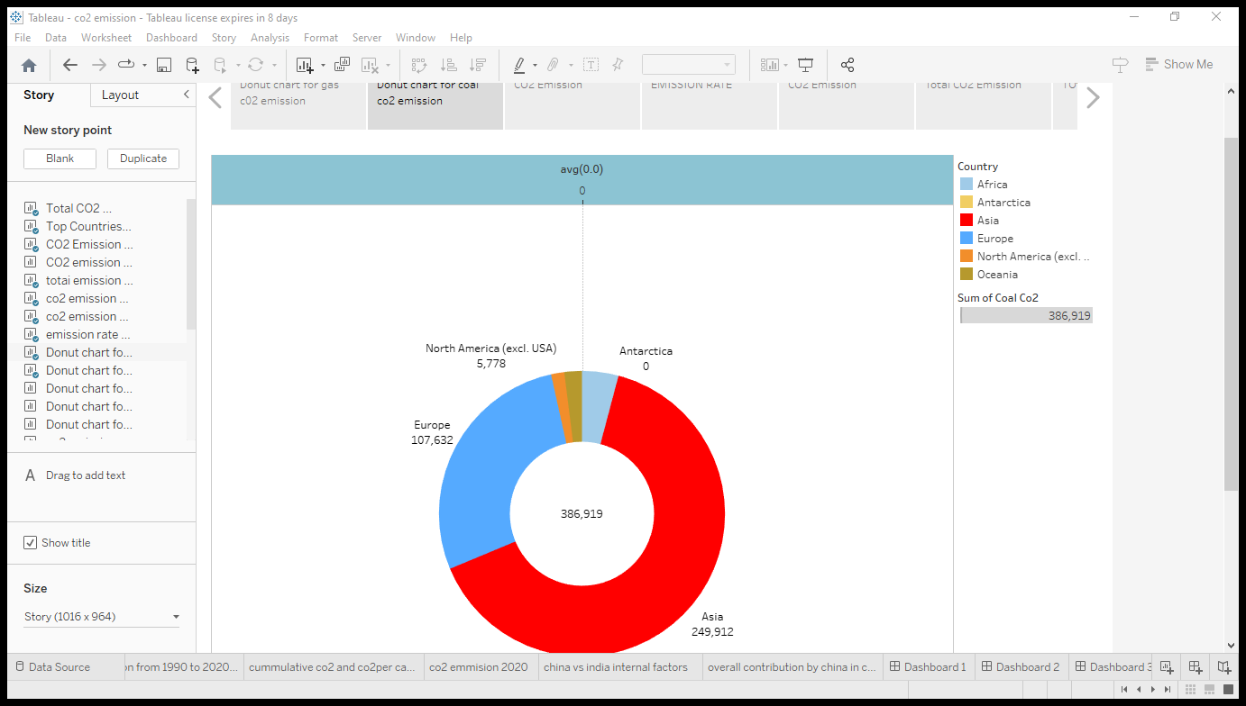

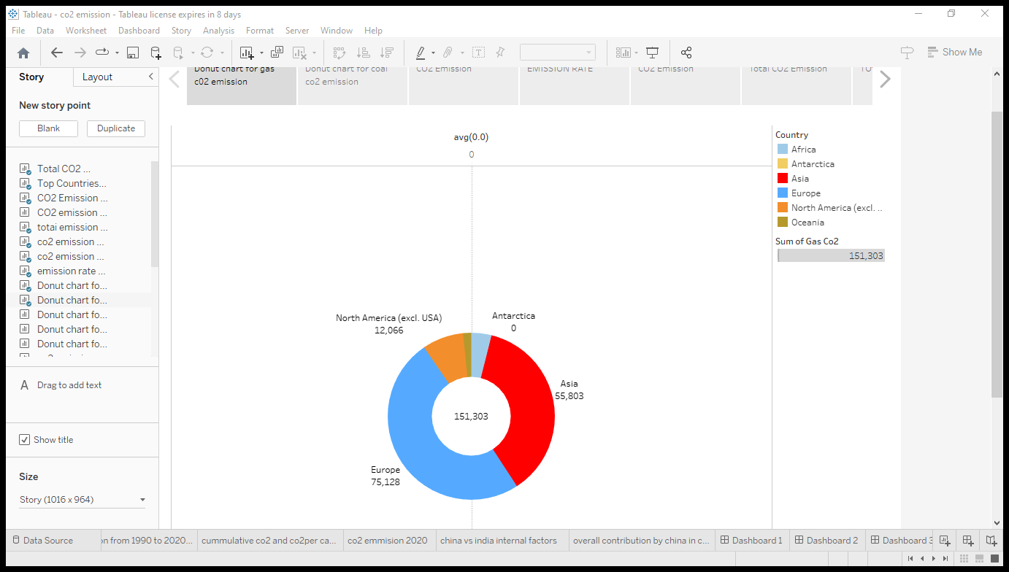

7.FUTURE SCOPE:

Reducing India’s Emissions:

* India has the lowest per capita emissions of the world’s major economies -- emitting 5% of the total, despite accounting for 17% of the world’s population.
* According to the World Resources Institute, India’s total greenhouse gas emissions were about 3.3 billion tonnes in 2018.
* It’s projected to rise above 4 billion tonnes per year by 2030.
* That would mean between now and 2030, India could be emitting anywhere between 35 to 40 billion tonnes at the current rates of growth.
* Cutting 1 billion tonnes would, therefore, represent a reduction of 2.5 to 3% in its absolute emissions in the business-as-usual scenario in the next nine years.

**India’s New Renewables Target:**

* In 2019 India announced that it would take up its installed capacity of renewable energy to 450 GW by 2030.
* At that time, India’s publicly stated target was 175 GW by the year 2022.
* The installed renewable capacity has been growing rapidly in the last few years, and the enhancement as per it pledge from 450 GW to 500 GW is not likely to be very challenging.
* The increase in the proportion of non-fossil fuel energy in the energy mix, to 50% is a natural corollary of this.
* Most of the new capacity additions in the energy sector are being done in the renewable and non-fossil fuel space.
* In fact, India has already said it does not plan to start any new coal power plants after 2022.
* As of now, India was already targeting 40% electricity
* production through non-fossil fuel sources by 2030.

**Climate Finance:**

* India's efforts though will have to be supported by the availability of climate finance from developed countries. Without foreign capital, on concessional terms, this transition will prove to be difficult.
* India demands USD 1 trillion of climate finance as soon as possible and will monitor not just climate action, but deliver climate finance.
* Most importantly, India has called, once again, for a change in lifestyles.

**Steps Needed to Achieve Net Zero:**

* According to the Council on Energy, Environment and Waters implications of a Net-zero Target for India's Sectoral Energy Transitions and Climate Policy' study, India's total installed solar power capacity would need to increase to over 5,600 gigawatts to achieve net-zero by 2070.
* The usage of coal, especially for power generation, would need to drop by 99% by 2060, for India to achieve net-zero by 2070.
* Consumption of crude oil, across sectors, would need to peak by 2050 and fall substantially by 90% between 2050 and 2070.
* Green hydrogen could contribute 19% of the total energy needs of the industrial sector.

8.APPENDIS:

* Source code:
* Dashboard:

<div class='tableauPlaceholder' id='viz1681895558424' style='position: relative'><noscript><a href='#'><img alt='Dashboard 2 ' src='https:&#47;&#47;public.tableau.com&#47;static&#47;images&#47;co&#47;co2emission_16818948918170&#47;Dashboard2&#47;1_rss.png' style='border: none' /></a></noscript><object class='tableauViz' style='display:none;'><param name='host_url' value='https%3A%2F%2Fpublic.tableau.com%2F' /> <param name='embed_code_version' value='3' /> <param name='site_root' value='' /><param name='name' value='co2emission_16818948918170&#47;Dashboard2' /><param name='tabs' value='no' /><param name='toolbar' value='yes' /><param name='static_image' value='https:&#47;&#47;public.tableau.com&#47;static&#47;images&#47;co&#47;co2emission_16818948918170&#47;Dashboard2&#47;1.png' /> <param name='animate_transition' value='yes' /><param name='display_static_image' value='yes' /><param name='display_spinner' value='yes' /><param name='display_overlay' value='yes' /><param name='display_count' value='yes' /><param name='language' value='en-US' /><param name='filter' value='publish=yes' /></object></div> <script type='text/javascript'> var divElement = document.getElementById('viz1681895558424'); var vizElement = divElement.getElementsByTagName('object')[0]; if ( divElement.offsetWidth > 800 ) { vizElement.style.width='100%';vizElement.style.height=(divElement.offsetWidth*0.75)+'px';} else if ( divElement.offsetWidth > 500 ) { vizElement.style.width='100%';vizElement.style.height=(divElement.offsetWidth*0.75)+'px';} else { vizElement.style.width='100%';vizElement.style.height='1327px';} var scriptElement = document.createElement('script'); scriptElement.src = 'https://public.tableau.com/javascripts/api/viz_v1.js'; vizElement.parentNode.insertBefore(scriptElement, vizElement);        </script>

* Story:

<div class='tableauPlaceholder' id='viz1681895521523' style='position: relative'><noscript><a href='#'><img alt='Story 1 ' src= 'https:&#47;&#47;public.tableau.com&#47;static&#47;images&#47;co&#47;co2emissionstory_16818953968040&#47;Story1&#47;1_rss.png' style='border: none' /></a></noscript><object class='tableauViz' style='display:none;'><param name='host_url' value='https%3A%2F%2Fpublic.tableau.com%2F' /> <param name='embed_code_version' value='3' /> <param name='site_root' value='' /><param name='name' value='co2emissionstory_16818953968040&#47;Story1' /><param name='tabs' value='no' /><param name='toolbar' value='yes' /><param name='static_image' value='https:&#47;&#47;public.tableau.com&#47;static&#47;images&#47;co&#47;co2emissionstory_16818953968040&#47;Story1&#47;1.png' /> <param name='animate_transition' value='yes' /><param name='display_static_image' value='yes' /><param name='display_spinner' value='yes' /><param name='display_overlay' value='yes' /><param name='display_count' value='yes' /><param name='language' value='en-US' /><param name='filter' value='publish=yes' /></object></div> <script type='text/javascript'> var divElement = document.getElementById('viz1681895521523'); var vizElement = divElement.getElementsByTagName('object')[0]; vizElement.style.width='1016px';vizElement.style.height='991px'; var scriptElement = document.createElement('script'); scriptElement.src = 'https://public.tableau.com/javascripts/api/viz_v1.js'; vizElement.parentNode.insertBefore(scriptElement, vizElement);        </script>